**Assignment 1&2**

**Saveetha school of engineering**

1.Converting Roman Numbers to integers

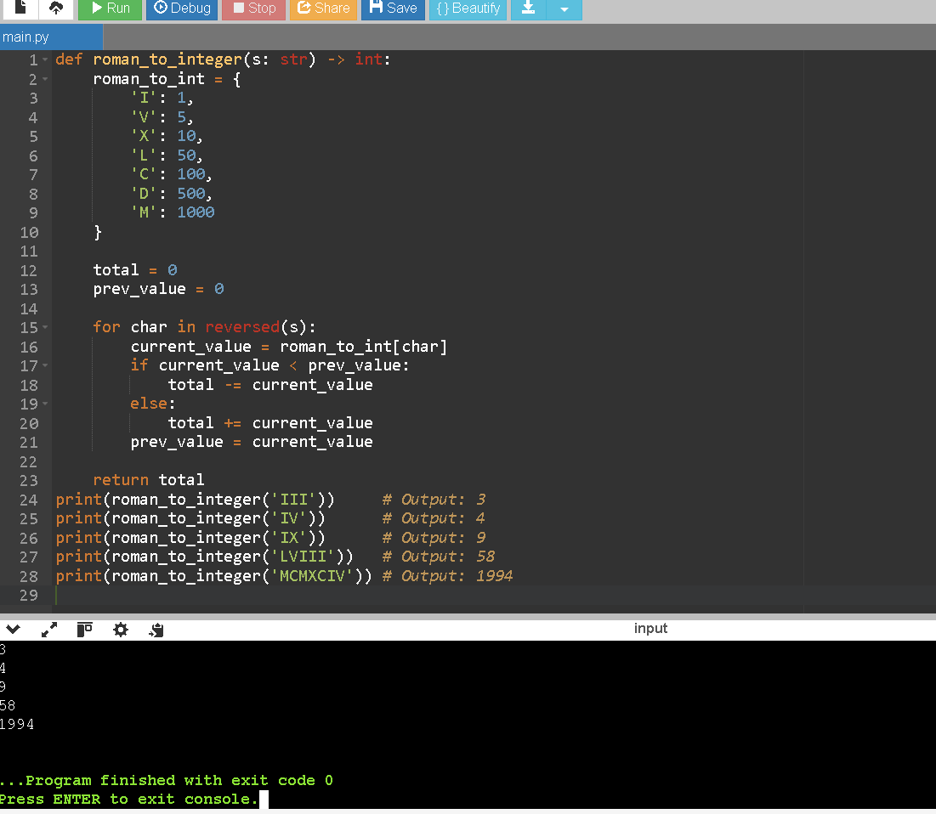

2.Bit Reserving

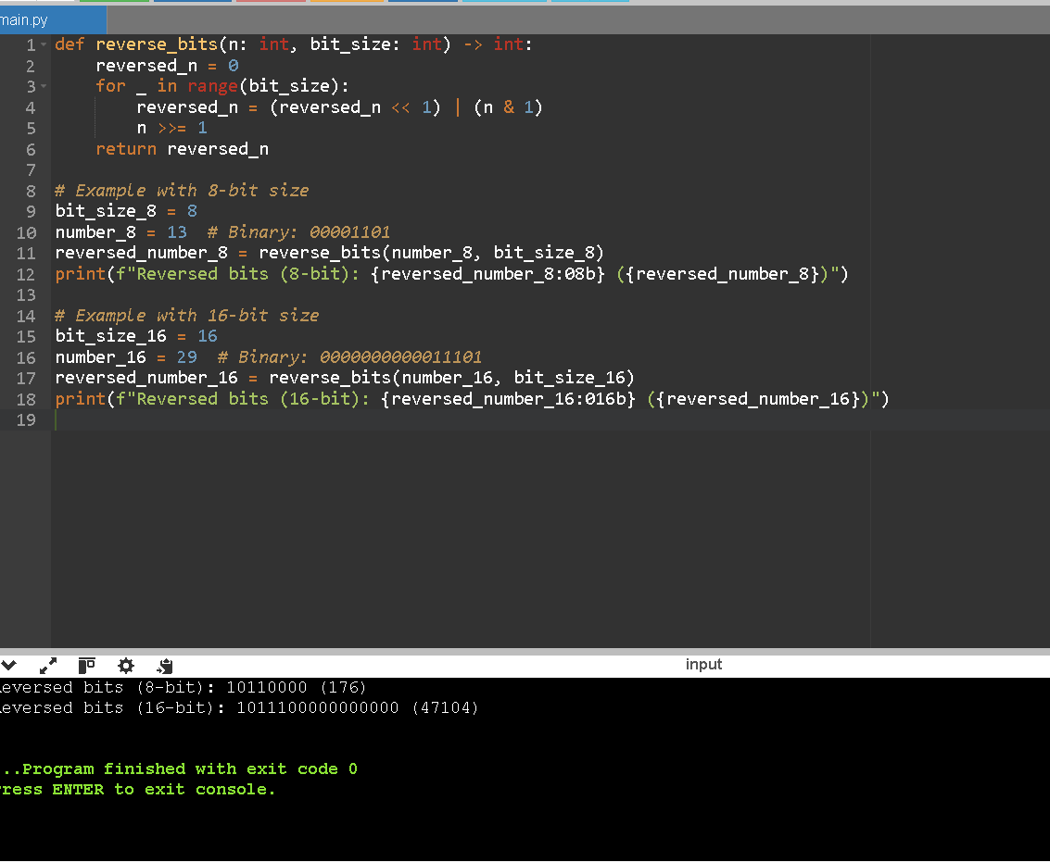

3. Given an integer array nums where the elements are sorted in ascending order, convert it to a height-balanced binary search tree.

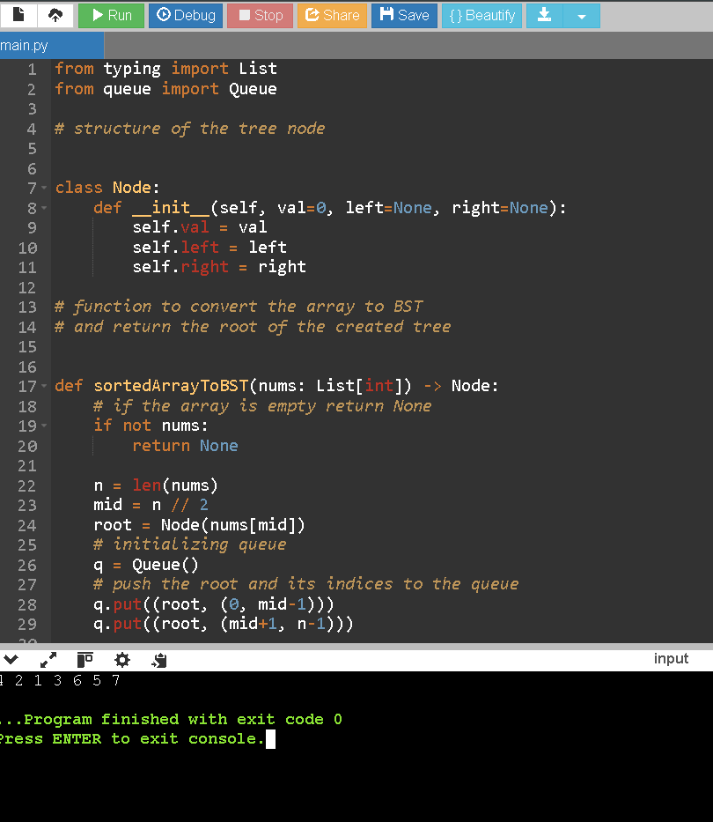

4.Given a binary tree, determine if it is height-balanced

"""

Python3 program to check if a tree is height-balanced

"""

# A binary tree Node

class Node:

# Constructor to create a new Node

def __init__(self, data):

self.data = data

self.left = None

self.right = None

# function to find height of binary tree

def height(root):

# base condition when binary tree is empty

if root is None:

return 0

return max(height(root.left), height(root.right)) + 1

# function to check if tree is height-balanced or not

def isBalanced(root):

# Base condition

if root is None:

return True

# for left and right subtree height

lh = height(root.left)

rh = height(root.right)

# allowed values for (lh - rh) are 1, -1, 0

if (abs(lh - rh) <= 1) and isBalanced(

root.left) is True and isBalanced(root.right) is True:

return True

# if we reach here means tree is not

# height-balanced tree

return False

# Driver function to test the above function

root = Node(1)

root.left = Node(2)

root.right = Node(3)

root.left.left = Node(4)

root.left.right = Node(5)

root.left.left.left = Node(8)

if isBalanced(root):

print("Tree is balanced")

else:

print("Tree is not balanced")

# This code is contributed by Shweta Singh

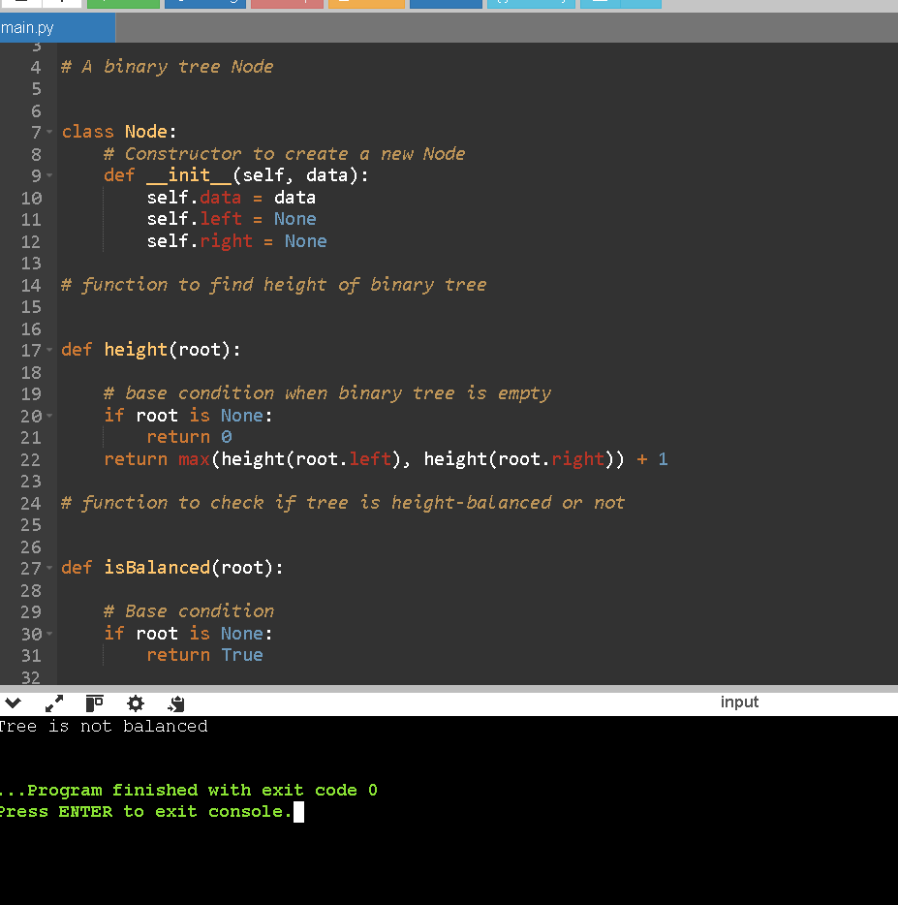

5.You are given an array prices where prices[i] is the price of a given stock on the ith day.

You want to maximize your profit by choosing a single day to buy one stock and choosing a different day in the future to sell that stock.

Return the maximum profit you can achieve from this transaction. If you cannot achieve any profit, return 0.

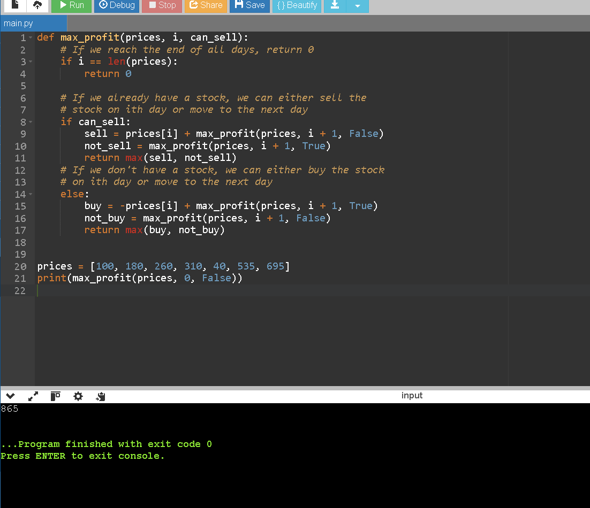

ASSIGNMENT 2

SAVEETHA SCHOOL OF ENGINEERING

1.Given two binary strings a and b, return their sum as a binary string.

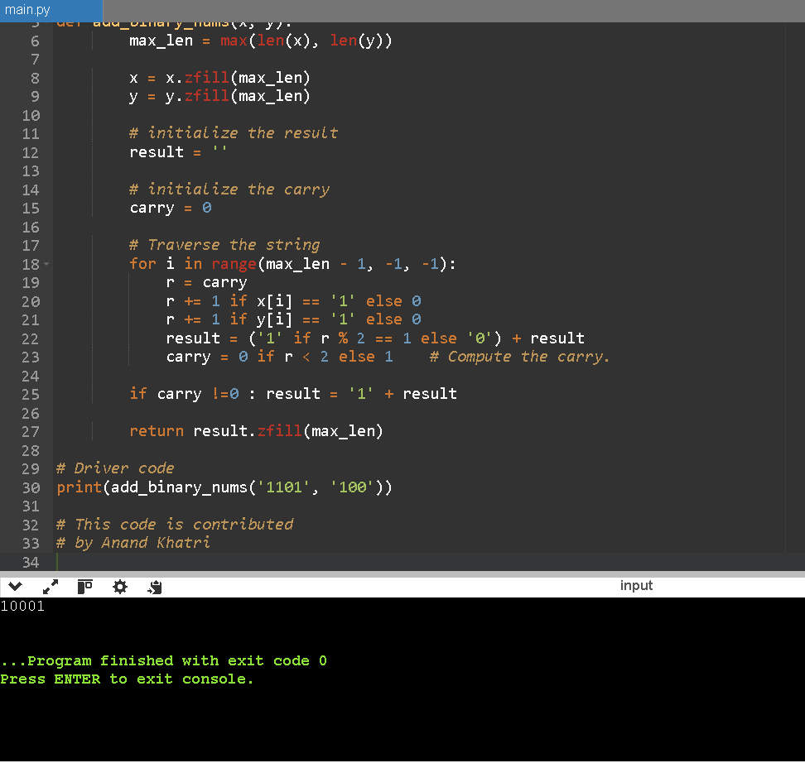

2.You are climbing a staircase. It takes n steps to reach the top. Each time you can either climb 1 or 2 steps. In how many distinct ways can you climb to the top?

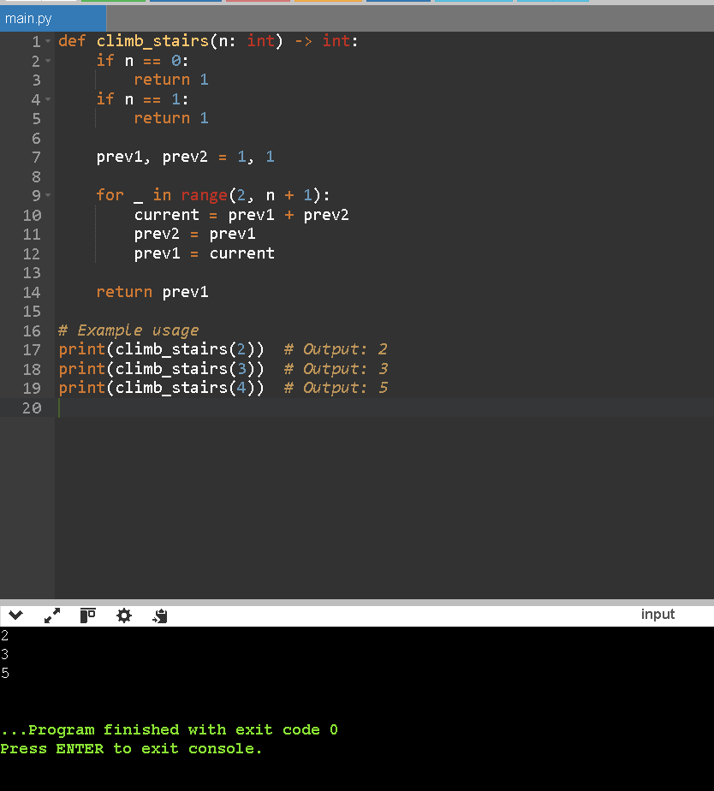

3. Write a function to find the longest common prefix string amongst an array of strings. If there is no common prefix, return an empty string "".

Example 1:

Input: strs = ["flower", "flow", "flight"]

Output: "fl"

Example 2:

Input: strs = ["dog", "racecar", "car"]

Output: ""

Explanation: There is no common prefix among the input strings

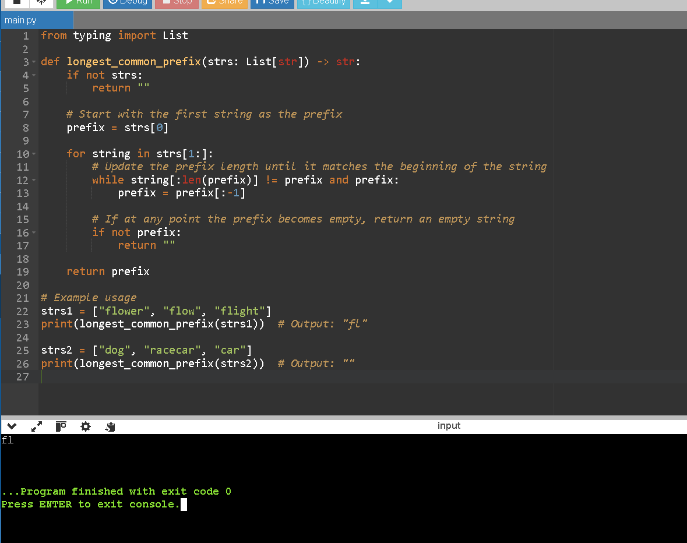

4. .Binary tree traversal

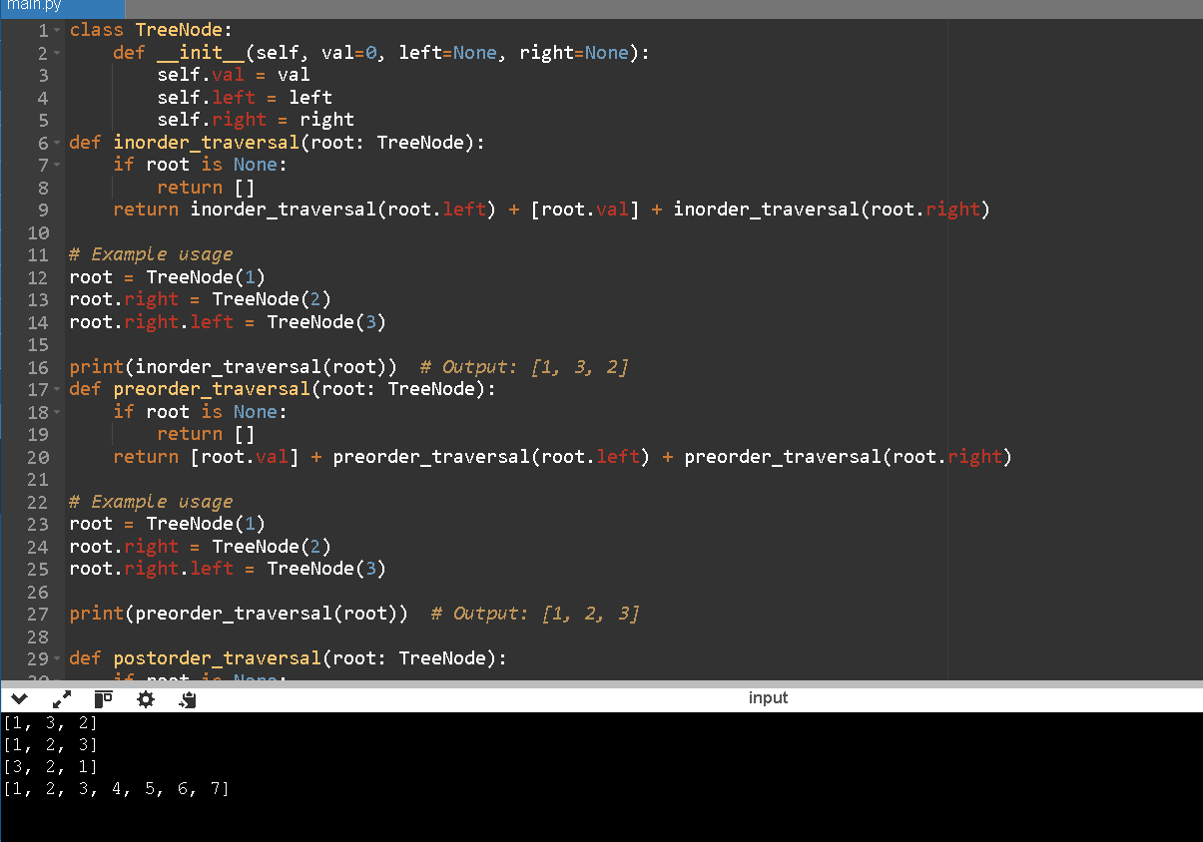

5. Given the root of a binary tree and an integer of targetsum return true if the tree has a root to leaf such that adding up all the values

